# CHAPTER ONE

# Introduction

This chapter reviews on the description of the project and some related background information on the project. Beside that this chapter observes the problem statement of the project to give a clear insight of what is the scope and objectives of the project. This chapter will become the guideline to all the work to be carried out in the later stage.

# 1.1 Background of the Study

The advancement in technologies and the fast pace globalization has led to higher institutions student either partially or fully in an online environment (Strauss, 2012). The recent growth in computer networks and more specifically, the World Wide Web (WWW) has given rise to communication, socialization and interaction between individuals via the internet. The internet is been used for several purposes these days ranging from education, business and so on, one major area that focuses on individual interaction and communication is an online website.

Base on record Computer Science department in Kaduna Polytechnic has been operating without a website since it was founded despite the undisputable fact that they have produced a lot of graduates who are now working in various sectors in and outside the country (ND and HND), it has also been passing information to staff and students directly (No access to departmental information outside the school environment) through memos and circulars which are usually placed on notice boards. Information about the lecturers, examination time table, students result, courses material for study, news and general announcement can only be gotten first hand while one is in school. This cause a lot of paper work and the notice board are usually full of information which could have easily be passed and accessed through a website within and outside the department or school.

This study will design and implement a website that will be used by the department in the dissemination of information such as date, venue and time for events like matriculation (both school and departmental), meetings (between staff and management or even management of the department and students) etc. course materials can be gotten by students from the website through various lecturer. Student can process departmental registrations online since the website will provide a powerful database for the storage of the information. Feedbacks as well as suggestions will also be received from the students and staff for the smooth running of the department as it heads towards paperless management and administration thereby making work and study a lot easier for both staff and students.

# 1.2 Motivation

This present era has been termed to be an information age, an age where the demand for information has dramatically increase, the internet has been the most useful place for getting information nowadays, we were motivated that a departmental online platform would solve some of the major problem faced by the department which are:

* The stress one has to go through just to get the information/materials from the department when one is not in the department or in school.
* The cost of parsing information with respect to semester examination result.
* Lack of a suitable platform for dissemination of information and a platform for informing the department of challenges, suggestions on how the department can move forward in its service to the students.

# 1.3 Purpose of the Study

The project is aimed at designing an online platform for Computer Science department Kaduna polytechnic. The functionalities are related to normal existing websites, this entails;

* Efficiently manage information about the department.
* Reduce the cost of parsing information.
* Establish a non-location based platform for lecturers and students.
* Aids in showcasing the department to the world.

# 1.4 Methodology

A careful study like this to discover new fact or information is known as research methodology. The research methodology used in this research work include direct observation about the department, the internet and textbooks. These methods provide reliable information and required knowledge for this research and proper guidance; HTML and CSS will be employed in designing the front-end, PHP and JavaScript technology will be used as the scripting language; MySQL will be used as the database (backend), XAMMP will be used as a local host or server. The combination of the above will help build a very robust platform that will be useful, fast and handy.

# 1.5 Scope of the Study

This project work is centered on developing a departmental website with the intention of eliminating the barriers to free dissemination and access to information that pertains to the department of Computer Science Kaduna polytechnic through an online website. The website will be able to generate forum, display latest news and others that had been mention in the background of this proposal. The people that are expected to fully utilize this portal are:

* Lectures
* Students
* Prospective students

# 1.6 Expected Contribution to Knowledge

**1. To the Students,**

Through this system, the students will be able to use the departmental website effectively for registering their personal information, courses registration and departmental registration. Example: It will also promote students easy access to information resources, materials etc.

**2. To the Faculty Members,**

Through this system, the faculty members can provide all the necessary information and resource material to their students and also be able to get the student information from the website.

**3. To the Future Researchers,**

The future researchers could gain knowledge from the study on the benefits, advantages and disadvantages, impact of developing website which they may apply to their research in the future.

# 1.7 Definition of Terms

**Website:** also written as web site, collection of related web pages, including multimedia content, typically identified with a common domain name, and published on at least one web server. (thefreedictionary.com 2011).

**Hypertext Markup Language (HTML):** HTML (Hypertext Markup Language) is a text-based approach to describing how content contained within an HTML file is structured. This markup tells a web browser how to display the text, images and other forms of multimedia on a webpage (thefreedictionary.com 2011).

**Hypertext Pre Processor (PHP):** PHP is a [script](https://whatis.techtarget.com/definition/script) language and interpreter that is freely available and used primarily on [Linux](https://searchdatacenter.techtarget.com/definition/Linux-operating-system) Web servers. PHP, originally derived from *Personal Home Page* Tools, now stands for *PHP: Hypertext Preprocessor*, which the PHP FAQ describes as a "recursive acronym." (thefreedictionary.com 2011).

**Common Gateway Interface (CGI):** The common gateway interface (CGI) is a standard way for a Web [server](https://whatis.techtarget.com/definition/server) to pass a Web user's request to an application program and to receive data back to forward to the user (thefreedictionary.com 2011).

**Information:** is any kind of event that affects the state of a dynamic system.

**Database:** it is a system intended to organize, store, and retrieve large amounts of data easily.

**XAMMP:** XAMPP is a free and open-source cross-platform web server solution stack package

# CHAPTER TWO

# Literature Review

# 2.1 Preamble

This chapter discuss on the studies related to web development. The general overview of web applications, concept of internet technology and website, it functions and benefits of a well design website. The chapter focuses on the study of website usability and comparison of existing system.

# 2.2 Web Development

(Robert, 2015) Web development is the coding or programming that enables website functionality, per the owner's requirements. It mainly deals with the non-design aspect of building websites, which includes coding and writing markup.

Web development ranges from creating plain text pages to complex web-based applications, social network applications and electronic business applications.

The web development hierarchy is as follows:

* Client-side Programming
* Server-side Programming
* Database technology

### Client-side programming

Client-side programming is the name for all of the programs which are run on the Client.

**Uses:**

1. Make interactive webpages.
2. Make things happen dynamically on the web page.
3. Interact with temporary storage, and local storage (Cookies, local Storage).
4. Send requests to the server, and retrieve data from it.
5. Provide a remote service for client-side applications, such as software registration, content delivery, or remote multi-player gaming.

**Example languages:**

1. JavaScript (primarily)
2. HTML
3. CSS
4. Any language running on a client device that interacts with a remote service is a client-side language.

HTML and CSS aren't really "programming languages" per-say. They are markup syntax by which the Client renders the page for the User.

### Server-side Programming

Server-side programming, is the general name for the kinds of programs which are run on the Server.

**Uses:**

1. Process user input.
2. Display pages.
3. Structure web applications.
4. Interact with permanent storage (SQL, files).

**Example Languages:**

1. PHP
2. Python
3. ASP.Net in C#, C++, or Visual Basic.
4. Nearly any language (C++, C#, Java). These were not designed specifically for the task, but are now often used for application-level web services.

**Database technology**

A database is an organized collection of [data](https://en.wikipedia.org/wiki/Data_(computing)), generally stored and accessed electronically from a computer system. Where databases are more complex they are often developed using formal [design and modeling](https://en.wikipedia.org/wiki/Database#Design_and_modeling) techniques.

**Example Languages:**

1. MySQL
2. SQLite
3. Oracle Databases

# 2.3 The Internet

Since the existences of Multimedia Super Corridor (MSC), Malaysia’s government strongly highlighted the importance of ICT among people and organization in Malaysia. Internet starts to boom and become a popular and competitive advantage to many organizations. In this world of technology, internet is a popular medium to access and share information. It is the easiest and fastest way to broadcast and retrieve information. Internet also provides unlimited access to anyone, any place and at any time (thefreedictionary.com 2017).

# 2.4 History of Website

The World Wide Web (WWW) was created in 1990 by the British CERN (European Organization for Nuclear Research) physicist Tim Berners-Lee on 30th April 1993 CERN announced that the World Wide Web would be free for use to anyone (Robert 2015).

Before the introduction of HTML and HTTP, other protocols such as File Transfer Protocol (FTP) and Gopher protocol were used to retrieve individual file from a server. Theses protocols offer a simple directory structure which the user navigate and chooses file to download. Documents were most often presented as plain text file without formatting, or were encode in word processor formats (Robert 2015).

# 2.5 Overview of Website

Website represents the basic delivery of online content. Websites depend on the fact that the user has a browser such as Chrome, Mozilla, Edge, Opera, Netscape or Internet Explorer but carry out most functionality on a server. The browser speaks HTTP and will render HTML’s code sent to it. A website may be accessible via a public internet protocol (IP) network, such as internet or a private local area network (LAN), by referencing a uniform resource locator (URL) that identifies the site. All publicly accessible websites collectively constitute the World Wide Web, while private websites are typically a part of an internet. A website is [hosted](https://en.wikipedia.org/wiki/Web_hosting_service) on a computer system known as a [web server](https://en.wikipedia.org/wiki/Web_server), also called an HTTP (Hyper Text Transfer Protocol) server. These terms can also refer to the software that runs on these systems which retrieves and delivers the web pages in response to requests from the website's users. [Apache](https://en.wikipedia.org/wiki/Apache_HTTP_Server) is the most commonly used web server software ([Netcraft](https://en.wikipedia.org/wiki/Netcraft" \o "Netcraft) statistics 2018). Websites have many functions and can be used in various fashions; a website can be a [personal website](https://en.wikipedia.org/wiki/Personal_website), a commercial website, a [government website](https://en.wikipedia.org/wiki/E-Government) or a [non-profit organization](https://en.wikipedia.org/wiki/Nonprofit_organization) website. Websites can be the work of an individual, a business or other organization, and are typically dedicated to a particular topic or purpose.

# 2.5.1 Static Website

A static website is one that has web pages stored on the server in the format that is sent to a client web browser. It is primarily coded in [Hypertext Markup Language](https://en.wikipedia.org/wiki/Hypertext_Markup_Language) (HTML); [Cascading Style Sheets](https://en.wikipedia.org/wiki/Cascading_Style_Sheets) (CSS) are used to control appearance beyond basic HTML. This type of website usually displays the same information to all visitors. Similar to handing out a printed brochure to customers or clients, a static website will generally provide consistent, standard information for an extended period of time. Although the website owner may make updates periodically, it is a manual process to edit the text, photos and other content and may require basic website design skills and software.

# 2.5.2 Dynamic Website

A dynamic website is one that changes or customizes itself frequently and automatically. There are a wide range of software systems, such as [CGI](https://en.wikipedia.org/wiki/Common_Gateway_Interface), JavaScript are available to generate [dynamic web systems and dynamic sites](https://en.wikipedia.org/wiki/Programming_languages_used_in_most_popular_websites). A site can display the current state of a dialogue between users, monitor a changing situation, or provide information in some way personalized to the requirements of the individual user. Dynamic sites can be interactive by using [HTML forms](https://en.wikipedia.org/wiki/HTML_forms), storing and reading back [browser cookies](https://en.wikipedia.org/wiki/Browser_cookies). An example of dynamic content is when a retail website with a database of media products allows a user to input a search request, e.g. for the keyword [Beatles](https://en.wikipedia.org/wiki/Beatles). In response, the content of the web page will spontaneously change the way it looked before, and will then display a list of Beatles products like CDs, DVDs and books. [Dynamic HTML](https://en.wikipedia.org/wiki/Dynamic_HTML) uses [JavaScript](https://en.wikipedia.org/wiki/JavaScript) code to instruct the web browser how to interactively modify the page contents.

# 2.6 Major Functions of Website

Website as earlier defined provides wide range of functions. According to Ovum (2016) the ideal website is based on eight functionality areas which are search and navigation, information integration, personalization, notification, task management and workflow, collaboration and groupware, integration of applications and business intelligence and infrastructure functionality. The project will only concentrate in three major functionalities which are search and navigation, personalization, and collaboration and groupware.

**Search and Navigation**

This functionality forms the basis for most of the successful public website meaning that a successful website should support its users in an efficient search for contents. The website should automatically present its users with the information appropriate to the user’s role and allow the user to search for information that was not previously known to be relevant to the user’s role, but which may be available through the website (Ovum 2016).

**Personalization**

Personalization should be based on user roles, as well as user preferences. Personalization of navigation should provide shortcuts to specific information; the design of personalization is such as the initial appearance of the website (Ovum 2016).

**Collaboration and Groupware**

Knowledge management and groupware ensure that the required information is stored in the right place and in the right mode. By this means the right persons are brought together with the right information. Groupware software assists in less formal collaboration than workflow tools (Ovum 2016).

# 2.7 Benefits of Well-Designed Websites

According to Liu & James (2016) Good websites not only attract and sell to customers, but also increase the potential of return visits. This raises important implications for organizations thinking of making an appearance on the internet (as well as presenting them with pertinent issues to keep in mind when designing their websites). Also, high quality websites lead to a favorable attitude towards the websites and product and services offered.

(Zona Research Inc., 2015) states that poorly constructed web sites can lead to lost revenue from non-realized transactions and a negative effect on organization image. (Zona Research Inc., 2015) concluded that poorly designed website can lose 50 percent of potential sales when people cannot find what they are looking for, and that 40 per cent of users do not return to website that uttered negative first experience.

# 2.8 Website Evaluation

This section presents an overview of criteria or features than can be used for evaluating website success.

1. **Clarity of purpose:** it must state clearly whether it is providing just information or whether it enables the customer to make transactions on-line (Zona Research Inc., 2015).
2. **Corporate Image:** The website should reflect the image that the company is trying to portray and which the customers will remember and return to (Zona Research Inc., 2015).
3. **Accessibility and speed:** This refers to the ability of customers to access the website of a particular e-business and navigates its site. The speed, which the home page and other pages are, downloaded (Zona Research Inc., 2015).
4. **Content:** What the website actually offers in terms of information. This is as important as the design aspects (Liu & James, 2016)
5. **Security and reliability:** it is crucial that any website should have a security policy accessible or offers a secure payment method online (Liu & James, 2016)
6. **Option for Communication:** With internet the face-to-face interaction is non-existent so companies offer a telephone number for customer to call or other means of contact (Liu & James, 2016).
7. **Personalization:** e-Business can tailor the website to a particular customer from the information gathered when customer visited the site. This allows e-Business to create relationship with customers (Liu & James, 2016).

# CHAPTER THREE

# Methodology and Design

# 3.1 Preamble

This is basically a presentation of end results of systems analysis (of the existing system) and design (of the new system) processes stating clearly the method and tools employed by the researcher. Method of data collection during this research includes studying the organizational principle and underlying rules. Object-Oriented Methodology is going to be used in this project considering the fact that today’s systems (programming languages) are majorly object oriented.

# 3.2 Method of Data Collection

In executing any system one has to have an insight of what is happening, it is important that information and fact about the existing system is gathered. In executing this research, two methods were employed

1. Observation method.
2. Internet.

# 3.2.1 Observation Method

This method was employed in gathering information/data for this research by seeing the way in which the manual system was carried out. The glaring issues with the existing system were detected by careful observation.

# 3.2.2 Internet

This method was employed in gathering information/data for the website development concerning as areas that seems difficult or confusing.

# 3.3 System Modelling

System model is the conceptual model as a result of the system modeling that describe and represent a system. A system describes a relationship between any set of component to achieve some common objective.

# 3.3.1 Use Case Diagram

The purpose of Use Case Diagram is to present a graphical overview of the functionality provided by a system in terms of actors, their goals (represented as use cases), and any dependencies between those use cases.

Admin

Staff

Student

Fig 3.1 System Use Case Diagram

# 3.3.2 Class Diagram

Class diagrams are visual representations of the static structure and composition of a particular system using the conventions set by the Unified Modeling Language (UML). Out of all the UML diagrams types, it is one of the most used ones. Using class diagrams, it is easier to describe all the classes, packages, and interfaces that constitute a system and how these components are interrelated. The top partition contains the name of the class; the middle part contains the class’s attributes while the bottom partition shows the possible operations that are associated with the class.

Login

- Username:String

- Password: String

+ Login():void

+cancel()

+ getAdminData()

Student

- RegNo: int

- StudentName: String

- Spin:int

- Level

+ reg()

+ manage()

+ addNews()

+ addResultSheet()

+getTotalStudet():int

Staff

- StaffId: int

- StaffName: String

- Username: String

- Password: String

- reg()

+ addNews()

+ manage()

+getTotalStaff():int

Figure 3.2 Admin Case Diagram

Student

- Level

+ addMaterials()

+ giveAssignment()

+ receiveAssignment()

+ manage()

+ passAnnouncement()

Login

- Username:String

- Password: String

+ login():void

+ viewNews()

+ ViewResultSheet()

+ logout()

Figure 3.3 Staff Case Diagram

Login

- RegNo:String

- Spin: int

+ login():void

+ deptReg()

+ courseReg()

+ receiveAssignment()

+ submitAssignment()

+ printExamCard()

+ viewResultSheet()

+ viewNews()

+ logout()

Figure 3.4 Student Case Diagram

# 3.3.3 Activity Diagram

**Login**

Accept Username

Accept Password

Grant Access

Match Not Found

Match Found

Figure 3.5 Login Activity Diagram

**Update Examination Result**

Save Details

Log in Admin Page

Add Result Sheet

Upload to Table

Discard Details

Logout

Figure 3.6 Update Examination Result Activity Diagram

**Update Study Material**

Save Details

Login in Staff Page

Add Downloadable

Discard Details

Upload to Table

Logout

Select level

Figure 3.7 Update Study Material Activity Diagram

**Course Registration**

Log into Student Page

Course Registration

Select semester and session

Add or Remove Courses

Register Courses

Print Registration Form

Figure 3.8 Course Registration Activity Diagram

**Departmental Registration**

Login Student Page

Dept. Registration

Not agreed

Make Payment

Payment means

Correct details

Enter OTP

Payment Breakdown

No Refund after Payment

Bank Branch

Card

Enter Card Details

Print Invoice

Payment Successful

Valid OTP

Invalid OTP

Figure 3.9 Course Registration Activity Diagram

Agreed

Incorrect details

Print Receipt

# 3.4 Input Design

This section describes various inputs that are needed by the new system from the user. The inputs expected from users of the new system are specified. These inputs are made up of characters which can either be numeric, alphanumeric and alphabetic.

This specification involves the creation of the files in which the various variables or field name to be used are specified together with their types and the specifications. The database that will be used in this project is SQL (Structured Query Language) in order to store various data. This technology is useful for several reasons, including the possibility of speedily and easily amending database. SQL standards are vital so that structured data will be uniform and independent of applications, the flexibility encountered in the use of the system as well as the ease in recalling and reading the data and ensuring applicability through the internet.

1. Admin Table: contains basic information about admin members registered.
2. Staff Table: contains basic information about registered staff
3. Student Table: contains basic information about registered students

|  |  |  |  |  |  |
| --- | --- | --- | --- | --- | --- |
| **Field Name** | **Data Type** | **Null** | **Key** | **Length** | **Description** |
| admin_id | Int | No | PK | 10 | Admin number |
| fname | Varchar | No |  | 20 | Admin first name |
| sname | Varchar | No |  | 20 | Admin surname |
| oname | Varchar | No |  | 20 | Admin other name |
| username | Varchar | No |  | 20 | Admin username |
| password | Varchar | No |  | 20 | Admin password |
| email | Varchar | No |  | 30 | Admin email |

Table 3.1 Admin

|  |  |  |  |  |  |
| --- | --- | --- | --- | --- | --- |
| **Field Name** | **Data Type** | **Null** | **Key** | **Length** | **Description** |
| staff_id | Int | No | PK | 10 | Staff number |
| fname | Varchar | No |  | 20 | Staff first name |
| sname | Varchar | No |  | 20 | Staff surname |
| oname | Varchar | No |  | 30 | Staff other name |
| username | Varchar | No |  | 30 | Staff username |
| password | Varchar | No |  | 200 | Staff password |
| email | Varchar | No |  | 30 | Staff email |

Table 3.2 Staff

|  |  |  |  |  |  |
| --- | --- | --- | --- | --- | --- |
| **Field Name** | **Data Type** | **Null** | **Key** | **Length** | **Description** |
| student_id | Int | No | PK | 10 | Student number |
| fname | Varchar | No |  | 20 | Student first name |
| sname | Varchar | No |  | 20 | Student surname |
| oname | Varchar | No |  | 30 | Student other name |
| regno | Varchar | No |  | 20 | Student registration number |
| spin | Varchar | No |  | 10 | Student spin |
| email | Varchar | No |  | 30 | Student email |

Table 3.2 Student

# 3.5 Output Design

The output is going to be designed in a way that it will be user friendly, responsive and attractive. It will also be well secured such that login will be required to access some level of contents.

**Home Page**

GO

Search………….........

**Home About profile Materials Login Contact**

Computer Science

Department

Design and implementation of a website for computer science department Kaduna polytechnic

**Carousel Slide**

Figure 3.9.1 Home Page

**Login Form**

LOGIN

Remember me

username

Login

---login---

password

RegNo

Login

---login---

Spin

LOGIN

Remember me

Admin / Staff Login Form

Student Login Form

Figure 3.9.2 Login Page

**Student Page**

Computer Science

Department

Design and implementation of a website for computer science department Kaduna polytechnic

Welcome : lastname + firstname

**Student Dashboard**

**Dept. Registration**

**Course Registration**

**Announcement**

**Assignment**

**Student Dashboard**

View Details

Dashboard

View Details

Dept. Registration

View Details

Course Registration

View Details

Announcements

View Details

Assignments

View Details

Print Exam Card

View Details

Print Result Sheet

**Print Result Sheet**

**Print Exam Card**

Figure 3.9.3 Student Page

**Staff Page**

Computer Science

Department

Design and implementation of a website for computer science department Kaduna polytechnic

Welcome : lastname + firstname

**Staff Dashboard**

**Notification**

**Give Assignment**

**Add downloadables**

**Announcement**

**Staff Dashboard**

View Details

Dashboard

View Details

Notification

View Details

Give

Assignment

View Details

Add downloadables

View Details

Annoucement

Check Result

Figure 3.9.4 Staff Page

**Admin Page**

Computer Science

Department

Design and implementation of a website for computer science department Kaduna polytechnic

Welcome : lastname + firstname

**Admin Dashboard**

**Student Report**

**Staff Report**

**Create Courses**

**Create Exam Card**

**Admin Dashboard**

View Details

Dashboard

View Details

Student Report

View Details

Staff Report

View Details

Create Courses

View Details

Create Exam Card

View Details

Admin Report

View Details

Add Exam Sheet

**Add Exam Sheet**

**Admin Report**

Figure 3.9.5 Admin Page

# 3.6 System Requirement

The system requirement is made up of two (2) specification, hardware and software specification.

# 3.6.1 The Hardware Requirement

System Hardware Requirement;

1. Minimum of Intel Dual core processor.
2. Minimum of 1 GB of RAM (Random Access Memory).
3. Minimum of 250GB HDD (Hard Disk Drive).

# 3.6.2 Software Requirement

Software Requirement;

1. At least window 7 OS.
2. Browsers includes: Chrome, Firefox.
3. XAMP

# 3.7 Choice of Programming Language

The choices of programming languages used involve HTML5, CSS3, JavaScript, PHP, MySQL and XAMMP. The reasons for choosing these programming languages is that it is a web base applications and require web programming language and are as follows:

1. HTML is the bedrock of Web Applications as it is the skeletal framework of a webpage. HTML5 is an updated version of it and it consist of various new tags that enable effective validation of forms and other functions that will assist JavaScript in some of it functions.
2. CSS3 is the latest version of the Cascading Style sheet that helps style the page and makes it display effectively on the screen of your device.
3. JavaScript is a client side scripting web language that is used for validation of forms and user inputs.
4. PHP (PHP Hypertext Preprocessor) is a server side scripting language that enables communication between the server and web page. It usually works with the MySQL to reach the database on the server.
5. XAMMP is a free and open-source cross platform that serves as a local host.

# CHAPTER FOUR

# System Implementation and Evaluation

# 4.1 Preamble

This section describes how the new system is implemented for effective operation. It shows a concise detail of the process of implementation and sample of the working (new) system designed.

# System Testing and Evaluation

**Integration Testing**

Testing of the program was implemented using integration testing all the units were put together as one so they function as one. The link between the various units were tested to be sure that they are correctly integrated, also to be sure that the units can function correctly together as one.

# 4.3 System Conversion Plan

The conversion of the new system is parallel approach i.e. both the existing and new system will be used concurrently before it finally has good stand in the system. This is used because having jumped out to new system directly with existing system completely out can cause breakdown to every record already taken during the cause of using the new system alone if there is any problem in the program maintenance.

# 4.4 System Installation

In order to use the proposed application on any computer system, the following steps need to be taken:

1. Boot the system.
2. Install XAMPP server on the system (XAMPP server is a local server).
3. After successful installation you will have a folder with the name XAMPP in the local or hard disk drive.
4. Copy your project folder to htdocs folder inside the XAMPP folder.
5. Open any browser on the system example Chrome, Microsoft Edge, Mozilla Firefox.
6. On the address bar, type <http://localhost/project> and press the enter key.

# 4.5 Security Measures

Since the scope of the website is public, some of the information such as index page, about us, materials e.t.c are available to anyone who visits the website. But some other information and functionalities such as registering/managing/student, staff and admin, viewing suggestions/complains, making departmental registration/course registration, submitting and retrieving assignment, viewing news e.t.c are restricted to some and not all who visit the website. The restrictions are carried out by the use of passwords which gives different level of access to users. The highest level of access is held by the admin, followed by the staff and then the student with lesser access.

# 4.6 Sample Outputs

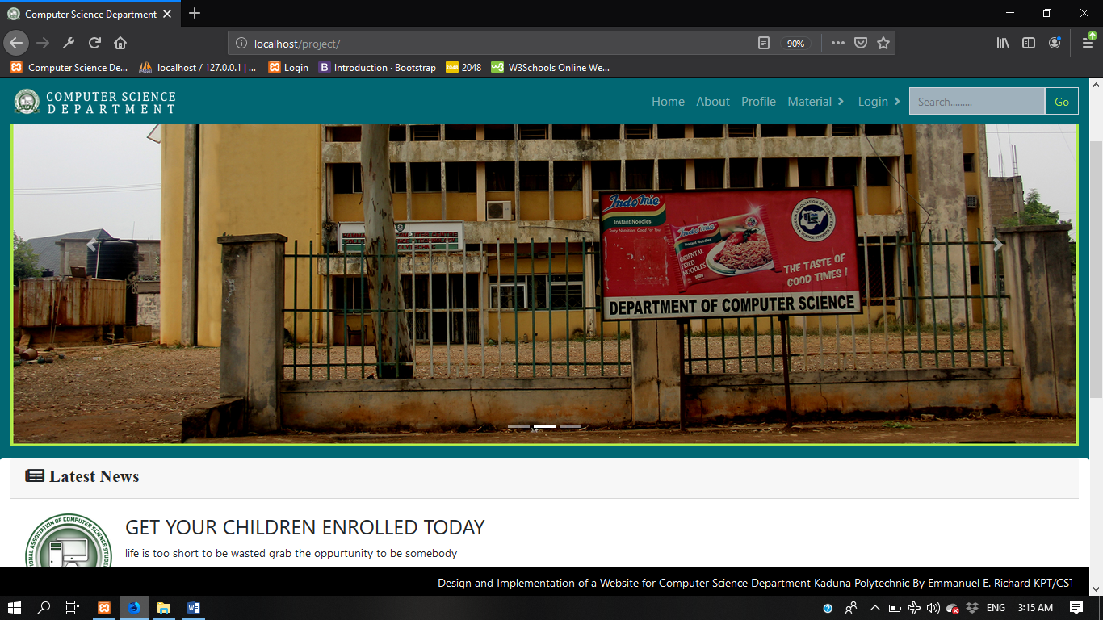

Fig 4.1 Home Page

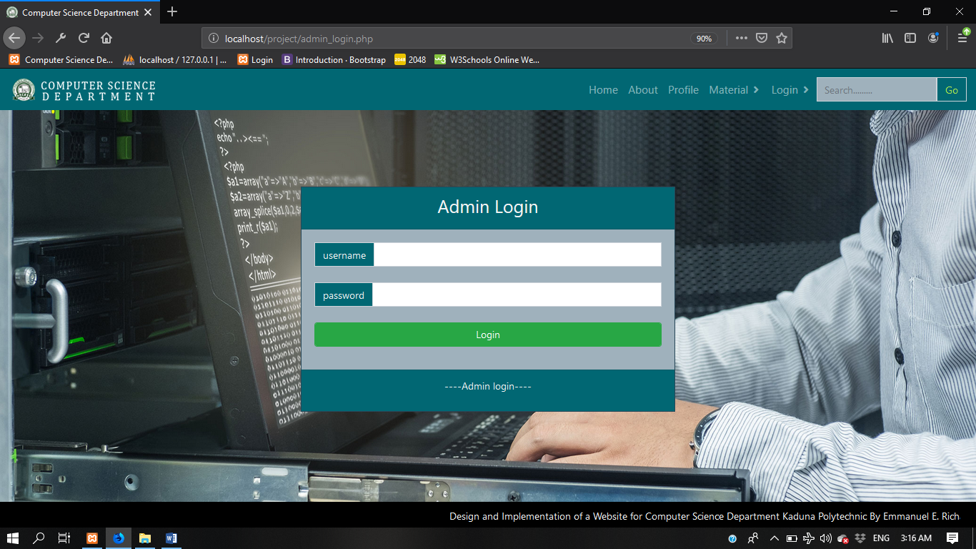

Fig 4.2 Admin Login

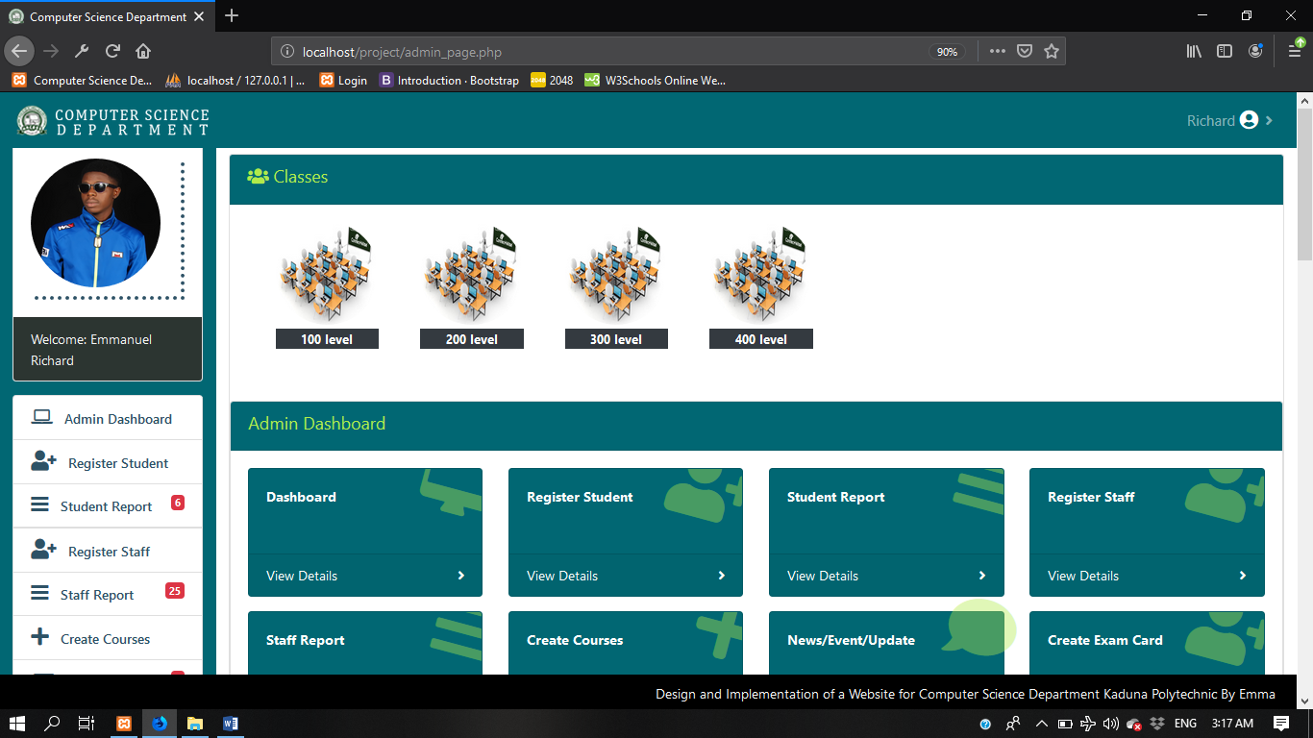

Fig 4.3 Admin Dashboard

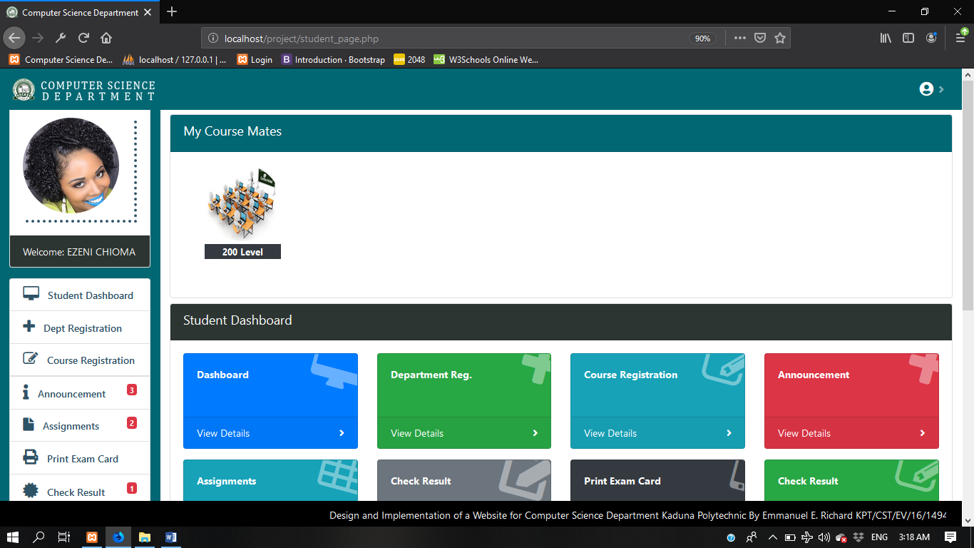

Fig 4.4 Student Dashboard

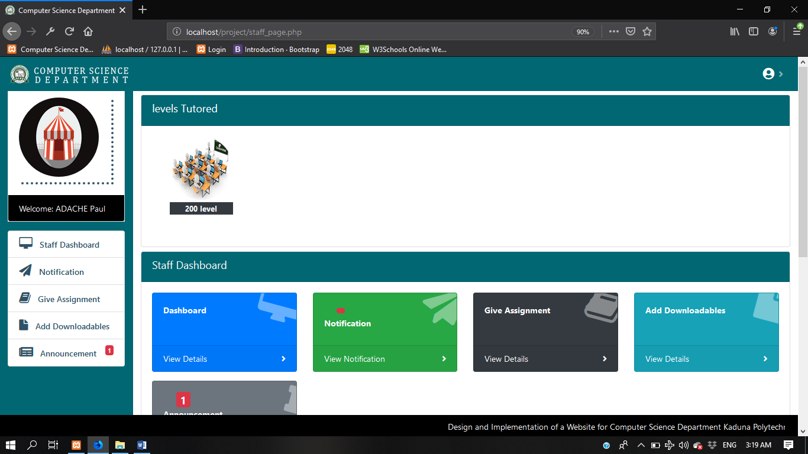

Fig 4.5 Staff Dashboard

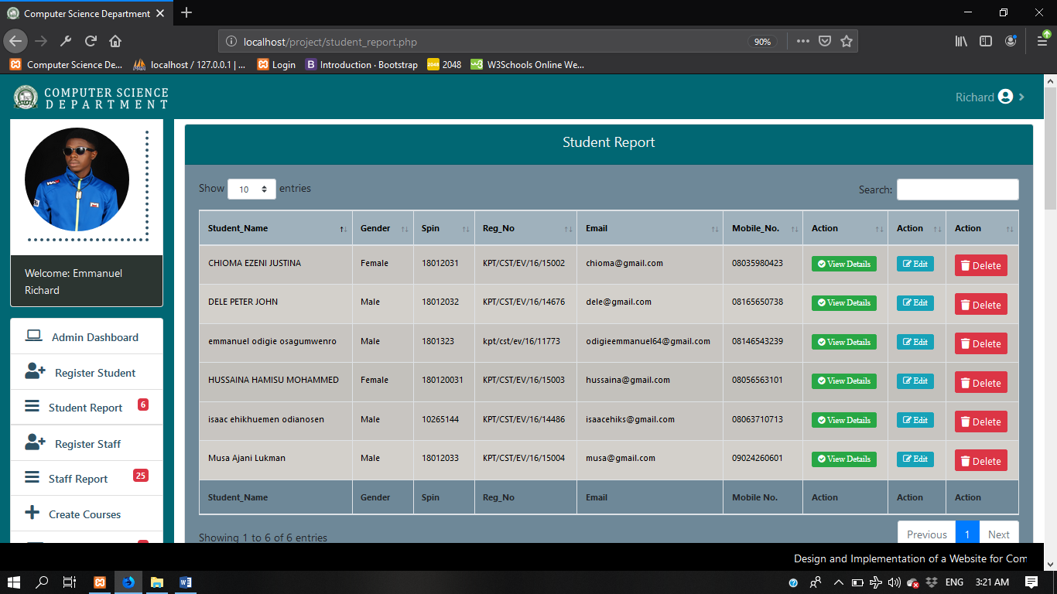

Fig 4.6 Student Report

# CHAPTER FIVE

# Summary Conclusion and Recommendation

# 5.1 Summary

This project is titled “Design and implementation of a website for computer science department” aimed to efficiently manage information about the department, reduce the cost of parsing information establish a non-location based platform for lecturers and students which can be implemented by a website. This work examines the challenges of the existing system and provides suitable solutions. It also shows the advantages and benefits of the proposed website for the department.

# 5.2 Conclusion

There have been many advances on communication and dissemination of information, the introduction of technology particularly in web which appears to be leaving a lasting impression on how the adoption of this technology would help in the growth of the department. It is clear that students are using the internet with increasing frequency, many with the goal of seeking information. It is therefore to advantage of the student, staff and even the management of the department if a website is built to handle the objectives of the project.

# 5.2 Recommendation

This project work is recommended to be adopted by every department in Kaduna polytechnic that are still operating on the manual method of dissemination of information to students and staff. The following are also recommended for further research:

1. Adding interactive forum/chat platform for educative discussion.
2. Adding a platform that teaches programming languages.

# REFERENCES

Strauss (2012). The advancement of technology. *The Turkish Online Journal of*

*Educational Technology.*

Web development Terms, thefreedictionary.com(2011). Technology. *The Turkish*

*Online Journal of Educational Technology.*

Robert (2015). Web development, client and side server programming.

[**^**](https://en.wikipedia.org/wiki/Database#cite_ref-10) [*"database, n"*](http://www.oed.com/view/Entry/47411). OED Online. Oxford University Press. June 2013*. Retrieved July*

*12,2013*. (Subscription required.)

Robert (2015). History and overview of website Oxford University Press. June 2013*.*

*Retrieved July 12,2013*. (Subscription required.)

Benefit of well-designed websites Liu & James (2016). The use of website in media

education. *The Turkish Online Journal of Education Technology.*

Website Evaluation Zona Research Inc., 2015. The Zonal research incorporation

journal of Technology.

Liu & James (2016). The evaluation of students’ perceptions of distance education.

*The Turkish Online.* Ken A. (2015). Head First Java. 2ndedn. O’Reilly Media.

Robin N. (2015). Learning PHP, MySQL & JavaScript: With JQuery, CSS & HTML5

(Learning Php, Mysql, Javascript, Css& Html5). 4thedn. O’Reilly Media.

# APPENDIX

-- phpMyAdmin SQL Dump

-- version 4.7.4

-- https://www.phpmyadmin.net/

--

-- Host: 127.0.0.1

-- Generation Time: Sep 01, 2019 at 08:05 PM

-- Server version: 10.1.28-MariaDB

-- PHP Version: 5.6.32

SET SQL_MODE = "NO_AUTO_VALUE_ON_ZERO";

SET AUTOCOMMIT = 0;

START TRANSACTION;

SET time_zone = "+00:00";

/*!40101 SET @OLD_CHARACTER_SET_CLIENT=@@CHARACTER_SET_CLIENT */;

/*!40101 SET @OLD_CHARACTER_SET_RESULTS=@@CHARACTER_SET_RESULTS */;

/*!40101 SET @OLD_COLLATION_CONNECTION=@@COLLATION_CONNECTION */;

/*!40101 SET NAMES utf8mb4 */;

--

-- Database: `nacoss`

--

-- --------------------------------------------------------

--

-- Table structure for table `admin`

--

CREATE TABLE `admin` (

`admin_id` int(11) NOT NULL,

`username` varchar(30) NOT NULL,

`password` varchar(255) NOT NULL,

`fname` varchar(50) NOT NULL,

`sname` varchar(50) NOT NULL,

`oname` varchar(50) NOT NULL,

`email` varchar(50) NOT NULL,

`phone` varchar(20) NOT NULL,

`gender` varchar(6) NOT NULL,

`dob` varchar(20) NOT NULL,

`marital` varchar(20) NOT NULL,

`address` varchar(255) NOT NULL,

`picture` varchar(250) NOT NULL,

`entry_date` timestamp NOT NULL DEFAULT CURRENT_TIMESTAMP ON UPDATE CURRENT_TIMESTAMP

) ENGINE=InnoDB DEFAULT CHARSET=latin1;

-- --------------------------------------------------------

--

-- Table structure for table `staff`

--

CREATE TABLE `staff` (

`staff_id` int(11) NOT NULL,

`fname` varchar(50) NOT NULL,

`sname` varchar(50) NOT NULL,

`oname` varchar(50) NOT NULL,

`email` varchar(50) NOT NULL,

`gender` varchar(6) NOT NULL,

`marital` varchar(10) NOT NULL,

`phone` varchar(14) NOT NULL,

`dob` int(14) NOT NULL,

`state` varchar(50) NOT NULL,

`position` varchar(20) NOT NULL,

`address` varchar(255) NOT NULL,

`username` varchar(50) NOT NULL,

`password` varchar(50) NOT NULL,

`picture` varchar(500) NOT NULL,

`entry_date` timestamp NOT NULL DEFAULT CURRENT_TIMESTAMP ON UPDATE CURRENT_TIMESTAMP

) ENGINE=InnoDB DEFAULT CHARSET=latin1;

-- --------------------------------------------------------

--

-- Table structure for table `student`

--

CREATE TABLE `student` (

`student_id` int(11) NOT NULL,

`fname` varchar(50) NOT NULL,

`sname` varchar(50) NOT NULL,

`oname` varchar(50) NOT NULL,

`email` varchar(50) NOT NULL,

`phone` varchar(20) NOT NULL,

`regno` varchar(20) NOT NULL,

`spin` int(10) NOT NULL,

`gender` varchar(6) NOT NULL,

`dob` varchar(11) NOT NULL,

`marital` varchar(20) NOT NULL,

`level` varchar(20) NOT NULL,

`state` varchar(50) NOT NULL,

`session` varchar(50) NOT NULL,

`address` varchar(255) NOT NULL,

`picture` varchar(255) NOT NULL,

`next_name` varchar(50) NOT NULL,

`next_gender` varchar(6) NOT NULL,

`relation` varchar(50) NOT NULL,

`next_phone` varchar(20) NOT NULL,

`sign` varchar(500) NOT NULL,

`entry_date` timestamp NOT NULL DEFAULT CURRENT_TIMESTAMP ON UPDATE CURRENT_TIMESTAMP

) ENGINE=InnoDB DEFAULT CHARSET=latin1;

/*!40101 SET CHARACTER_SET_CLIENT=@OLD_CHARACTER_SET_CLIENT */;

/*!40101 SET CHARACTER_SET_RESULTS=@OLD_CHARACTER_SET_RESULTS */;

/*!40101 SET COLLATION_CONNECTION=@OLD_COLLATION_CONNECTION */;

<!DOCTYPE html>

<html lang="en" style="height: 100%;">

<?php include'include/head_tag.php'; ?>

<body style="font-size: 100%; line-height: 1.5em; height: 100%; background-color: #016773; ">

<!--Navigation-->

<?php include'include/index_nav.php'; ?>

<!--End of Navigation-->

<section style="height: 90%; margin-top: 40px;">

<div class="container-fluid">

<div class="row">

<div class="col-md-12">

<div class="carousel slide" data-ride="carousel" id="homepage_slide">

<ol class="carousel-indicators">

<li class="active" data-slide-to="0" data-target="#homepage_slide"></li>

<li data-slide-to="0" data-target="#homepage_slide"></li>

<li data-slide-to="1" data-target="#homepage_slide"></li>

</ol>

<div class="carousel-inner">

<div class="carousel-item active">

<img src="img/CSTT.jpg" style="width: 100%;">

<div class="carousel-caption">

</div>

</div>

<div class="carousel-item">

<img src="img/Deptt.jpg" style="width: 100%;">

</div>

</div>

<a href="#homepage_slide" class="carousel-control-prev" data-slide="prev" role="button">

<span class="carousel-control-prev-icon" aria-hidden="true"></span>

<span class="sr-only">Previous</span>

</a>

<a href="#homepage_slide" class="carousel-control-next" data-slide="next" role="button">

<span class="carousel-control-next-icon" aria-hidden="true"></span>

<span class="sr-only">Previous</span>

</a>

</div>

</div>

</div>

</div>

</section>

<section id="news">

<div class="container-fluid">

<div class="row">

<div class="card col-lg-12" style="border-radius: 0;">

<div class="card-header" style="border-radius: 0;">

<h4 class="fas fa-newspaper-o"> Latest News</h4>

</div>

<div class="card-body">

<div class="col-lg-12 mb-3 table table-bordered mt-2 table-hover">

<div class="row">

<div class="col-lg-1">

<img src="img/<?php echo $row["pic"]; ?>" class="img-responsive" width="150" height="150">

</div>

<div class="col-lg-10 ml-5">

<h3 class=""><?php echo $row["title"]; ?></h3>

<span><?php echo $row["post"]; ?><br>

<a href=""></a>

</span>

</div>

</div>

</div>

</div>

</div>

</div>

</div>

</div>

</section>

<!--End of Banner-Section-->

<section id="semi-footer" style="background: #000000;">

<div class="container-fluid">

</div>

</div>

</div>

</div>

</section>

</body>

</html>